Test Phase Problem Statement

You are required to develop a “Mobile phone Repository” which contains mobile phone data stored in database. You have to use PHP/Jscript/C# code, HTML forms and MongoDB/MySQL database.
The main page of this system must a login interface. User must login to proceed to Home page.
After logging into system, user must be able to store the mobile phone data in database using HTML form.
After inserting mobile phone data, the user can perform the following functionalities:
- Retrieve mobile phone records
- Display records of mobile phone having price greater than 10,000 and less than 20,000
- Display records of mobile phone having price greater than 20,000.

PHP code must have the following functionalities:
- Connection to database
- Insert mobile phone records to database
- Retrieve all mobile phone records
- Records of mobile phone having price greater than 10,000 and less than 20,000
- Records of mobile phone having price greater than 20,000

Connection to database: It should have functionality to connect to database
Insert mobile phone records to database: It should have functionality to insert mobile phone data to database.
Retrieve all mobile phone records: It should retrieve all mobile phone records from database and then display all records.
Records of mobile phone having price greater than 10,000 and less than 20,000:
It should display all mobile phone records having salary greater than 10,000 and less than 20,000
Records of mobile phone having price greater than 20,000:
It should display all mobile phone records having salary greater than 20,000
Database will have two tables.
- First table will have usernames and respective passwords.
- 2nd table will have the Employee data which has four properties ID, Name, Age and Salary.

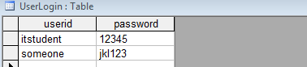

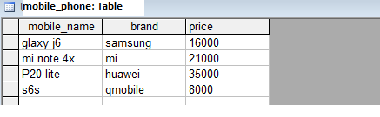

Remember you have to apply following concepts for the test phase:

Syntax and Logical errors
Exception Handling
Forms/GUIs
Database Operations [Create, Read, Update, Delete etc.]

